D.RADIUS & TACACS+ : TACACS+ & RADIUS Features, RADIUS Authentication Process, TACACS+ Use Cases, RADIUS vs. TACACS+
Tasks
1.Create a comparison table listing at least 4 key features of RADIUS and TACACS+ side by side, highlighting which protocol supports each feature.

Feature | RADIUS | TACACS+
Protocol Type | Open standard protocol supported by many vendors. | Cisco-developed protocol (widely supported but primarily associated with Cisco devices).
Transport Protocol | Uses UDP (Ports 1812 and 1813). | Uses TCP (Port 49).
Encryption | Encrypts only the user password during authentication. | Encrypts the entire packet, providing better security.
Authentication and Authorization | Combines authentication and authorization processes. | Separates authentication, authorization, and accounting processes.
Accounting Support | Supports accounting and logging of user activities. | Supports detailed accounting and logging of administrator actions.
Device Administration | Commonly used for network access control, VPNs, and WiFi authentication. | Commonly used for router, switch, and firewall administration.
Security Level | Good security but limited packet encryption. | Higher security due to full packet encryption.
Granular Access Control | Provides basic authorization controls. | Provides detailed command-by-command authorization.

2.Draw a step-by-step flow diagram showing the RADIUS authentication process for a user logging in to a public WiFi hotspot, labeling each communication step between the client, network device, and RADIUS server.
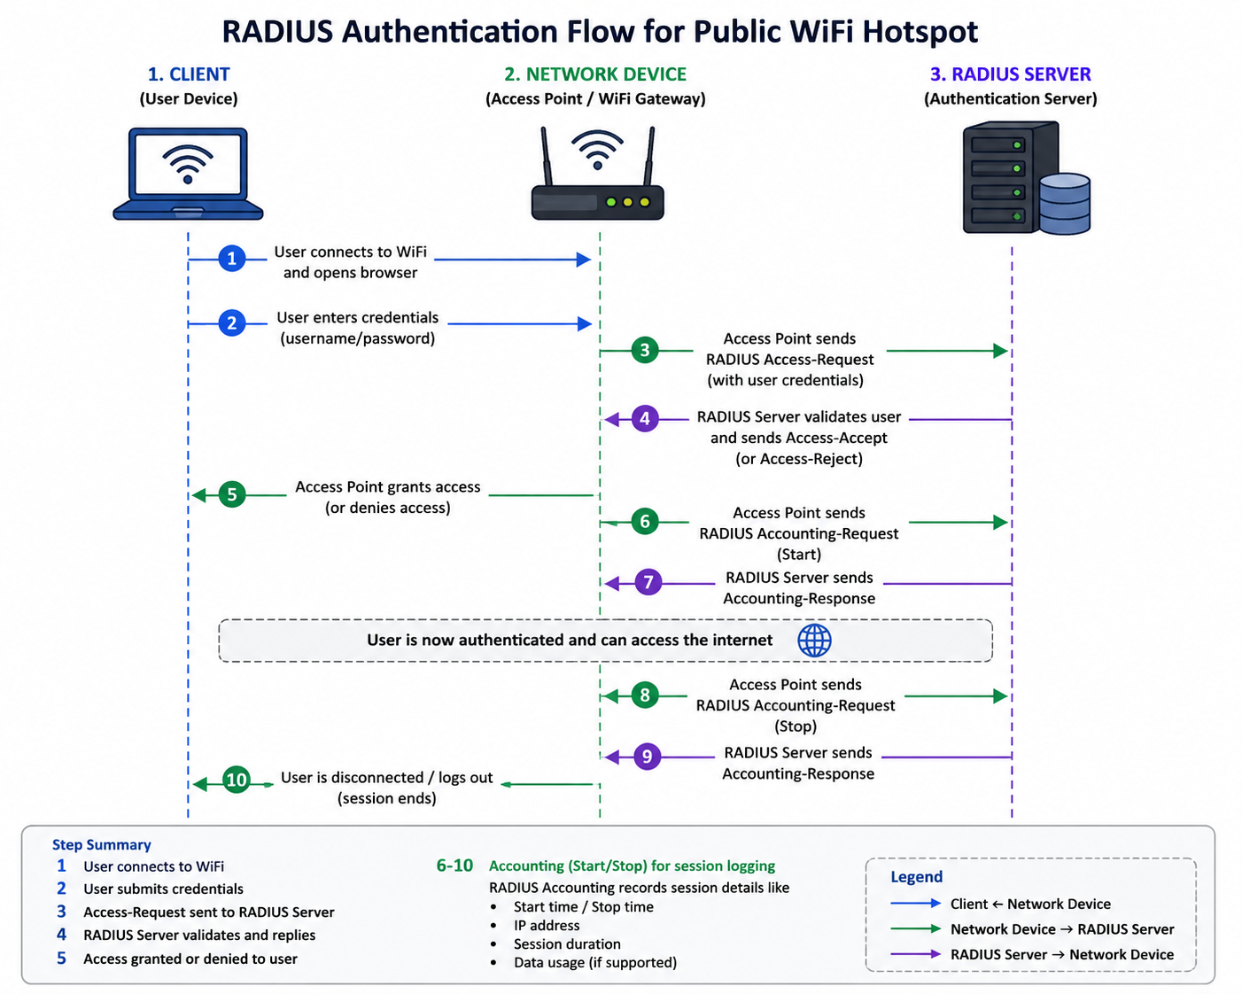
The diagram shows how RADIUS (Remote Authentication Dial-In User Service) authenticates a user when connecting to a public WiFi hotspot.
Step 1: The user connects their laptop or mobile device to the WiFi network and opens a web browser.
Step 2: The user enters their login credentials, such as a username and password, on the hotspot login page.
Step 3: The Access Point (Network Device) receives the credentials and sends a RADIUS Access-Request message to the RADIUS Server.
Step 4: The RADIUS Server verifies the user's credentials against its database. If the credentials are correct, it sends an Access-Accept message; otherwise, it sends an Access-Reject message.
Step 5: Based on the server's response, the Access Point either grants or denies access to the user.
Step 6: Once access is granted, the Access Point sends a RADIUS Accounting-Request (Start) message to the RADIUS Server to begin recording the user's session details.
Step 7: The RADIUS Server acknowledges the accounting request and starts logging information such as login time, IP address, and session details.
Step 8: While the user is connected, the RADIUS Server continues tracking usage information such as session duration and data consumption.
Step 9: When the user disconnects or logs out, the Access Point sends a RADIUS Accounting-Request (Stop) message to the RADIUS Server.
Step 10: The RADIUS Server records the session end time and final usage statistics, completing the accounting process.
3.List 3 real-world use cases where TACACS+ is preferred over RADIUS, and briefly explain why TACACS+ is better suited for each scenario.
3 Real-World Use Cases Where TACACS+ is Preferred Over RADIUS
1. Network Device Administration (Routers and Switches)
Example: A company uses Cisco routers and switches across multiple offices.
Why TACACS+ is Better:
- TACACS+ provides command-by-command authorization, allowing administrators to control exactly which commands a user can execute.
- Different administrators can be given different privilege levels.
- The entire communication packet is encrypted, providing better security.
2. Data Center and Enterprise Network Management
Example: A large organization manages hundreds of network devices in its data center.
Why TACACS+ is Better:
- TACACS+ separates Authentication, Authorization, and Accounting (AAA), making management more flexible.
- It keeps detailed logs of every administrative action performed on network devices.
- Helps organizations meet security and compliance requirements.
3. Internet Service Provider (ISP) Network Operations
Example: An ISP's network engineers remotely manage core routers and firewalls.
Why TACACS+ is Better:
- Provides detailed accounting records showing who accessed a device and what commands were executed.
- Supports role-based access control for different engineering teams.
- Offers stronger security through full packet encryption, protecting sensitive network management traffic.

4.Given a scenario where a user tries to log into a network device but fails authentication, describe how RADIUS and TACACS+ would handle the logging and response differently. Hint: Focus on how each protocol manages accounting and command authorization.
RADIUS vs TACACS+ Authentication Failure Scenario
Suppose a network administrator tries to log in to a router using an incorrect password.
With RADIUS, the router sends the login request to the RADIUS server for authentication. Since the credentials are incorrect, the RADIUS server returns an Access-Reject message, and the user is denied access. RADIUS logs the failed authentication attempt, including details such as the username, time, and device used. However, because the user never successfully logged in, there are no command authorization logs. RADIUS is mainly focused on network access authentication and basic accounting.
With TACACS+, the router sends the login request to the TACACS+ server. The server verifies the credentials and, if they are incorrect, denies access. TACACS+ records detailed logs of the failed login attempt, including the user, device, date, and reason for failure. Since TACACS+ separates Authentication, Authorization, and Accounting, it provides more detailed auditing information. If the user had successfully logged in, TACACS+ could also track every command executed on the device through command-level authorization and accounting.
Difference: RADIUS mainly logs the authentication failure and denies network access, while TACACS+ provides more detailed logging and auditing capabilities. TACACS+ is especially useful for network device administration because it can record and control individual commands, whereas RADIUS is primarily designed for user network access authentication.
5.Use ChatGPT or another AI tool to generate a sample RADIUS configuration snippet for a Cisco router, then review the output and list any changes you would make to adapt it for a college campus WiFi setup.
RADIUS Configuration and Adaptation for Campus WiFi
Introduction

RADIUS (Remote Authentication Dial-In User Service) is widely used in enterprise and campus networks to provide centralized authentication, authorization, and accounting (AAA). It is especially important in WiFi environments where multiple users need secure and controlled access to the network.

This section provides a sample Cisco RADIUS configuration and evaluates how it can be adapted for a college campus WiFi deployment.
1. Sample RADIUS Configuration (Cisco Router)

Below is a basic RADIUS configuration snippet for a Cisco device
aaa new-model

radius server RADIUS-SERVER
address ipv4 192.168.10.10 auth-port 1812 acct-port 1813
key cisco123

aaa authentication login default group radius local
aaa authorization network default group radius
aaa accounting exec default start-stop group radius

interface GigabitEthernet0/1
description Connected to Access Point
ip address 192.168.1.1 255.255.255.0
no shutdown
2. Explanation of Configuration

aaa new-model
Enables AAA services on the router.

radius server
Defines the RADIUS server IP address and shared secret key.

authentication login default group radius local
Uses RADIUS for authentication, with local fallback if the server is unavailable.

authorization network default group radius
Controls user access after authentication.

accounting exec default start-stop group radius
Logs user session activity.
interface configuration
Connects the router to the network (e.g., access points).
3. Limitations of the Basic Configuration
While the above configuration works in a simple setup, it is not fully suitable for a large-scale college campus environment because:

- Uses a **weak shared key (cisco123)**
- No encryption enhancements
- No user segmentation (students, staff, guests)
- No redundancy for RADIUS servers
- Lacks integration with directory services (like LDAP/Active Directory)
4. Improvements for College Campus WiFi Setup

To adapt this configuration for a college campus, the following changes should be made:
1. Use Strong Shared Secret
- Replace simple passwords with complex keys
- Example: `key Str0ng@CampusKey!2026`
- Prevents unauthorized access to the RADIUS server
2. Add Redundant RADIUS Servers
radius server RADIUS-BACKUP
address ipv4 192.168.10.11 auth-port 1812 acct-port 1813
key Str0ng@CampusKey!2026
- Ensures high availability
- Prevents authentication failure if one server goes down
3. Enable Secure Authentication Methods (802.1X)
- Use WPA2/WPA3 Enterprise with RADIUS
- Enforces per-user authentication instead of shared passwords
4. Integrate with Central User Database
- Connect RADIUS with:
- Active Directory
- LDAP
Allows centralized management of student and staff credentials
5. Implement Role-Based Access Control
- Assign different access levels:
- Students → Internet only
- Faculty → Internal resources + Internet
- Guests → Limited access
6. Enable Logging and Monitoring
- Use accounting logs for:
- Tracking user sessions
- Troubleshooting issues
- Security audits
7. VLAN Assignment via RADIUS
- Dynamically assign VLANs:
- Student VLAN
- Staff VLAN
- Guest VLAN
- Improves network segmentation and security
8. Improve Security with Encryption**
- Use protocols like:
- EAP (Extensible Authentication Protocol)
- PEAP or EAP-TLS
- Prevents credential exposure
5. Importance in Campus WiFi Environment

In a college campus:
- Thousands of users connect daily
- Sensitive academic and administrative data is transmitted
- Unauthorized access must be strictly controlled

RADIUS ensures:

- Secure authentication
- Centralized user management
- Scalable network access control

